Possessive Adjectives

🔹 What Are Possessive Adjectives?
# Source: AI Source: Provided by: [Data Path: Persons Table -> ID Column: 1, Name_En Column: Motasem Essam] -> From: [Chatgpt (GPT-4-turbo)] on [7/27/2025]
Possessive adjectives are words that show ownership or possession.
They describe to whom something belongs and always come before a noun.

✅ List of Possessive Adjectives
# Source: AI Source: Provided by: [Data Path: Persons Table -> ID Column: 1, Name_En Column: Motasem Essam] -> From: [Chatgpt (GPT-4-turbo)] on [7/27/2025]
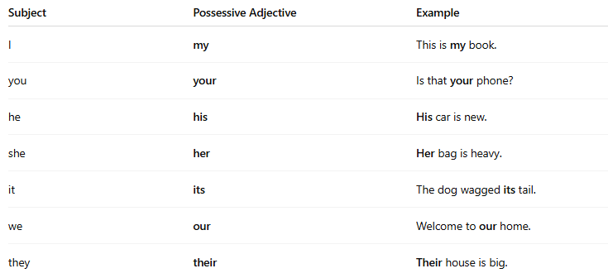
Subject | Possessive Adjective | Example
I | my | This is my book.
you | your | Is that your phone?
he | his | His car is new.
she | her | Her bag is heavy.
it | its | The dog wagged its tail.
we | our | Welcome to our home.
they | their | Their house is big.

📚 Examples in Sentences
# Source: AI Source: Provided by: [Data Path: Persons Table -> ID Column: 1, Name_En Column: Motasem Essam] -> From: [Chatgpt (GPT-4-turbo)] on [7/27/2025]
- My brother is a teacher.
- Your shoes are under the bed.
- She forgot her keys.
- The cat licked its paw.
- We cleaned our classroom.
- They sold their car.

❗ Important Notes
# Source: AI Source: Provided by: [Data Path: Persons Table -> ID Column: 1, Name_En Column: Motasem Essam] -> From: [Chatgpt (GPT-4-turbo)] on [7/27/2025]
- Possessive adjectives are not followed by apostrophes (e.g., its ≠ it's)
✅ The dog wagged its tail.
❌ The dog wagged it's tail. (wrong)
- They must always be followed by a noun.
✅ That is my pen.
❌ That pen is my. (→ should be mine, a possessive pronoun)

